Measuring the Pulse of Prosperity: An Index of Economic Freedom Analysis

Team ID : LTVIP2026TMIDS24940
Team Size : 4
Team Leader : BYREDDY MOKSHITH
Team member : CHATRAGADDA LIKHITHA
Team member : ILLGUNOORI VIMALA
Team member : MEDURI NAGA VENKATA BALAJI

1. Project Title
Measuring the Pulse of Prosperity: An Index of Economic Freedom Analysis

2. Introduction
Economic development differs significantly across countries. Some nations achieve high income levels, stable employment, and better living standards, while others experience economic instability, unemployment, and low growth. One important factor often associated with these differences is economic freedom.
The Index of Economic Freedom evaluates countries using multiple institutional and policy indicators such as property rights, tax burden, regulatory efficiency, and trade openness. However, the index provides rankings and scores without clearly showing how these indicators relate to actual economic performance.
This project analyzes the Index of Economic Freedom dataset using Tableau dashboards and stories. The goal is to provide a visual and data-driven understanding of how economic freedom relates to national prosperity indicators such as GDP per capita, unemployment rate, and inflation.

3. Problem Statement
Global economic datasets contain multiple variables across many countries, making them difficult to interpret using spreadsheets or static tables. Users cannot easily identify patterns, correlations, or economic relationships from raw data.
As a result, conclusions about economic policies are often based on theory rather than data analysis. There is a need for an interactive visualization system that allows users to explore economic freedom indicators and understand their relationship with economic performance.

4. Objectives
• Analyze global economic freedom indicators across countries
• Compare economic freedom with GDP per capita
• Study the relationship between economic freedom and unemployment
• Identify top and bottom performing economies
• Understand regional economic differences
• Create an interactive Tableau dashboard and story
• Publish analysis through Tableau Public

5. Dataset Description
The dataset used is the Index of Economic Freedom dataset containing country-level economic indicators.
Dataset Link:https://drive.google.com/file/d/1EBIa1LtM3Ni2Uh3nekLB6wt3263Q3NeX/view
Important Attributes
• Economic Freedom Score
• Property Rights
• Judicial Effectiveness
• Government Integrity
• Tax Burden
• Business Freedom
• Trade Freedom
• Investment Freedom
• Financial Freedom
• GDP per Capita
• Inflation Rate
• Unemployment Rate
• Public Debt and FDI indicators
Each row represents one country and its economic performance indicators.

6. Tools and Technologies Used
• Microsoft Excel – Data cleaning and preparation
• Tableau Desktop – Visualization and dashboard creation
• Tableau Public – Publishing and sharing dashboard
• Web Browser – Accessing and interacting with dashboard

7. System Requirements
Hardware
• Minimum 4GB RAM (8GB recommended)
• Personal computer or laptop
Software
• Windows or macOS
• Tableau Desktop / Tableau Public
• Internet Browser (Chrome / Edge)

8. Methodology / Project Workflow
- Dataset collection and inspection
- Data cleaning and preprocessing in Excel
- Importing dataset into Tableau
- Creating visualizations (scatter plots, maps, bar charts)
- Designing dashboard layout
- Adding filters and interactions
- Creating story points
- Publishing on Tableau Public
- Testing and validation

9. Visualizations Created
• 2022 Economic freedom score
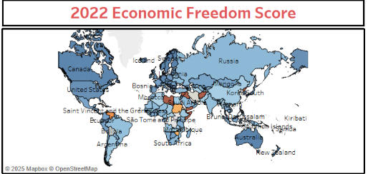

• Top 40 ranking countries in the index
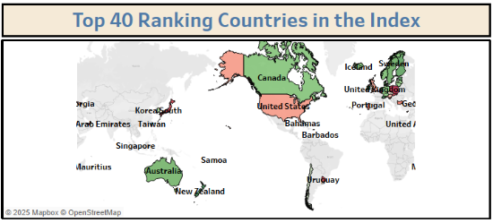

• Bottom ranking countries in the index
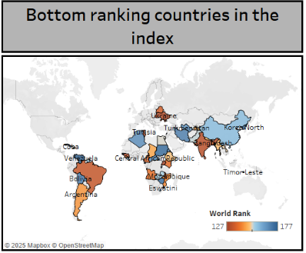

• Index score based on unemployment rate
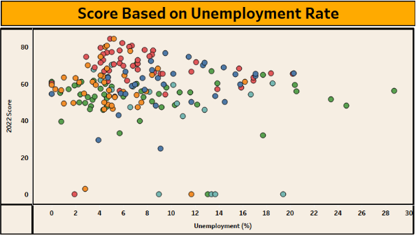
• Index score based on financial freedom
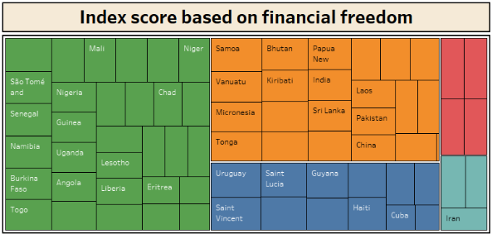

• Index score based on population
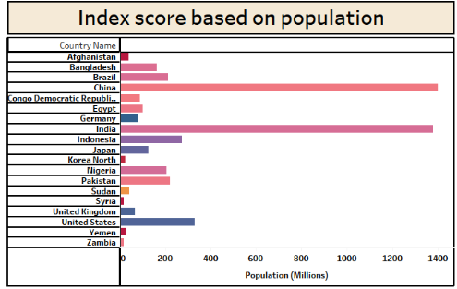

• Index score based on 5 year on GDP growth rate(%)
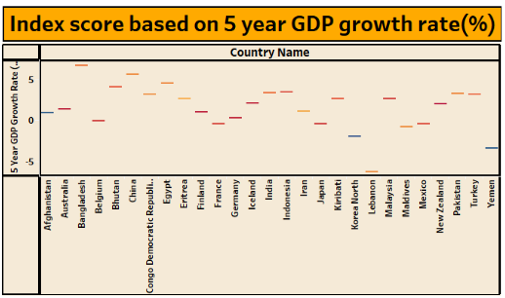

• Inflation rate in different countries
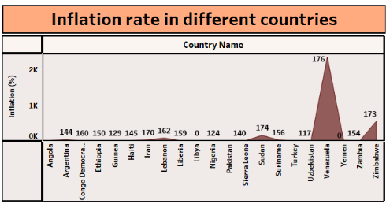
• Correlation between inflation and unemployment
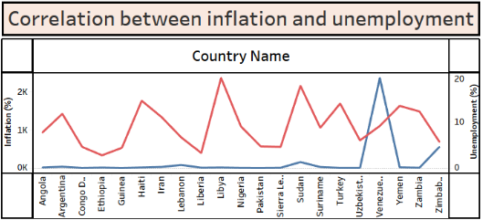

• Correlation between GDP(PPP) and monetary freedom
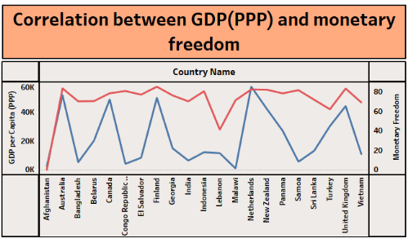

• Top 40 countries by GDP growth rate
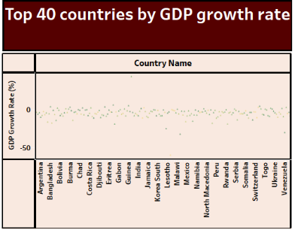

10. Dashboard Description
The dashboard integrates multiple charts into a single interactive analytical interface.
It allows users to:
• Compare countries
• Filter by region
• Observe economic relationships
• Identify patterns in development
Interactive filters:
• Country
• Region
• Indicator
Dashboard Link:
https://public.tableau.com/app/profile/lakshmi.supriya.jonnalagadda/viz/MyDashboards_17509586290130/Dashboard1

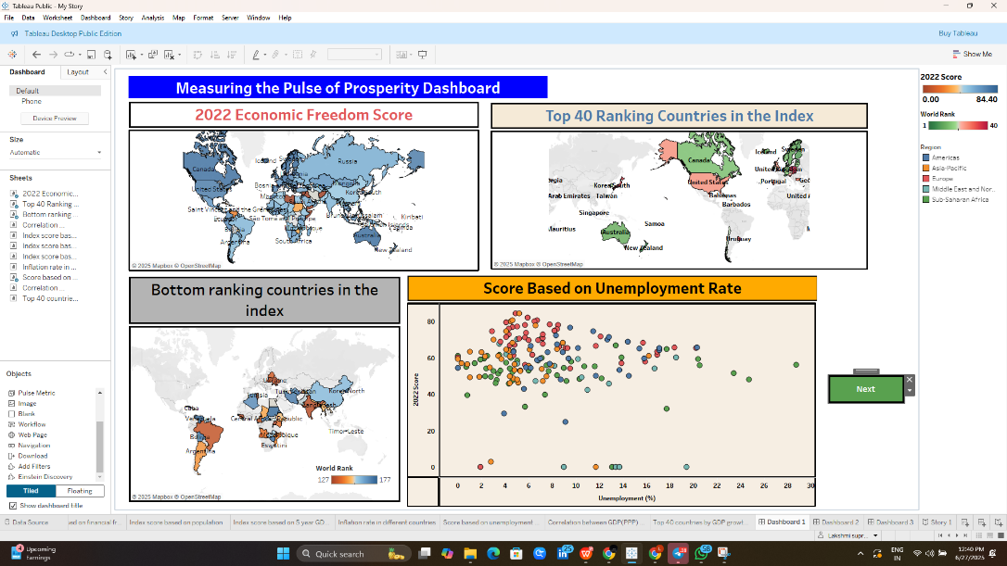

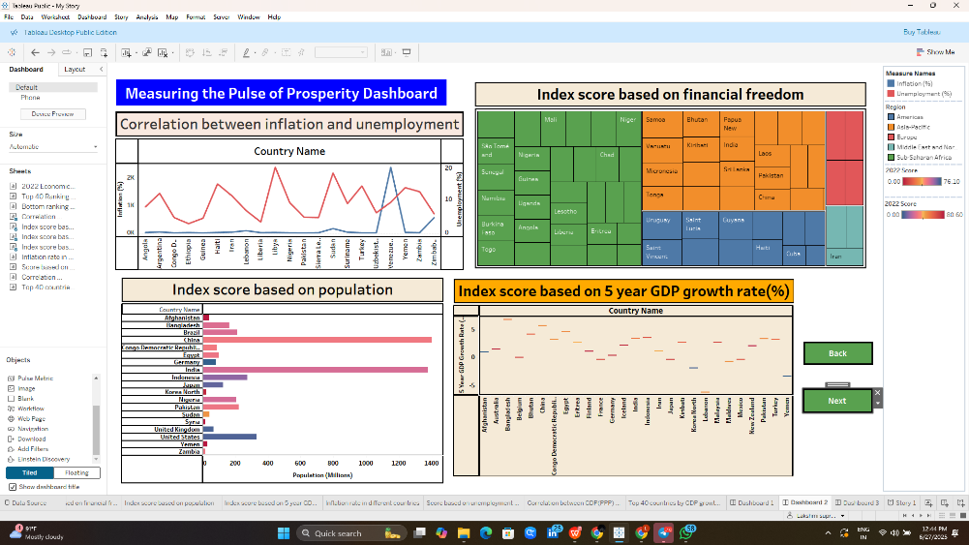

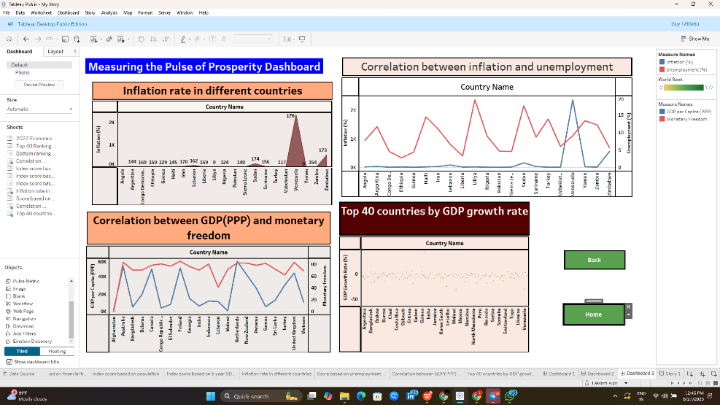

11. Story Description
A Tableau story presents insights step-by-step:
- Overview of Economic Freedom
- Income Relationship
- Regional Analysis
- Institutional Indicators
- Employment Impact
- Final Conclusion
The story helps users understand economic relationships logically instead of analyzing raw tables.
Story Link:
https://public.tableau.com/app/profile/lakshmi.supriya.jonnalagadda/viz/MyStory_17509593255230/Story1

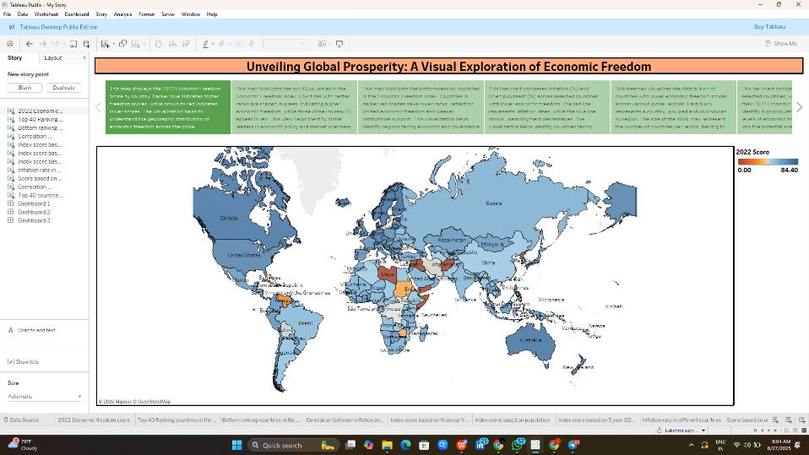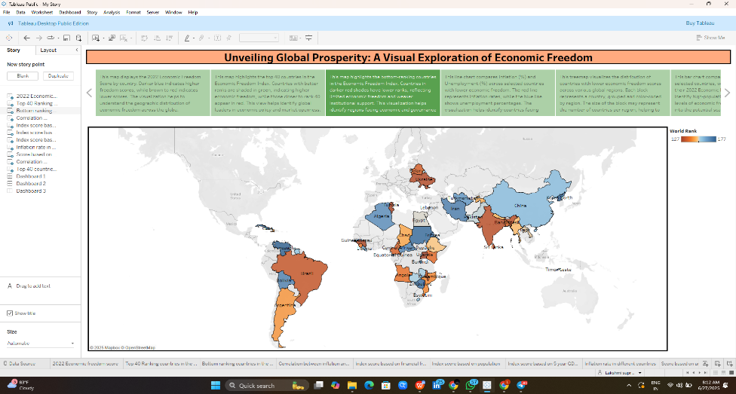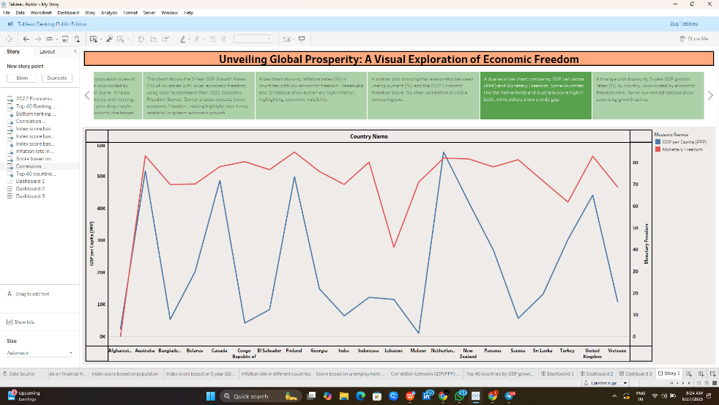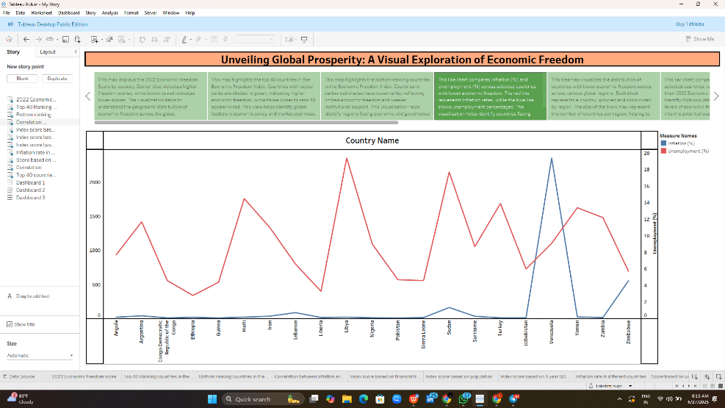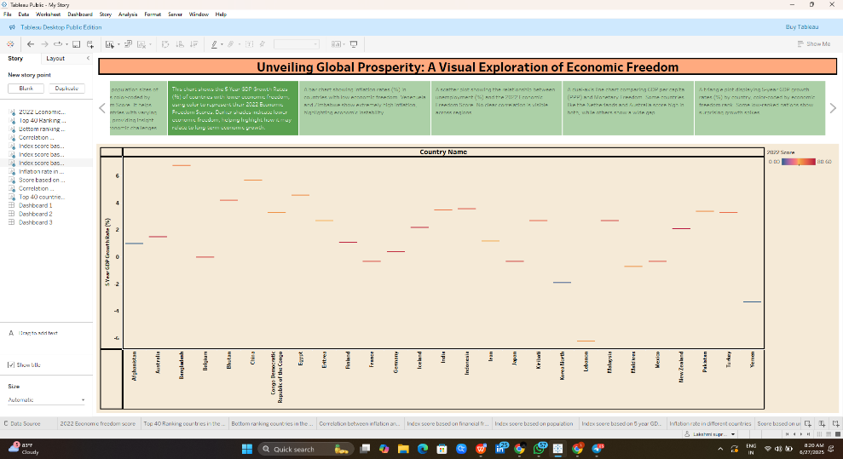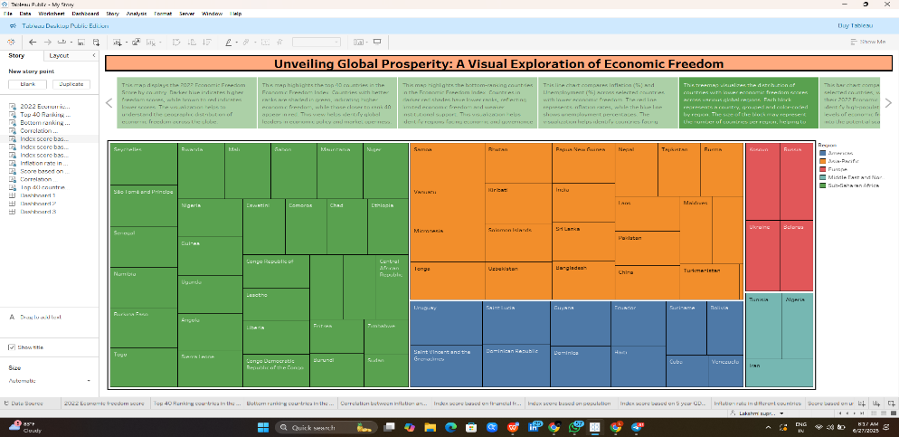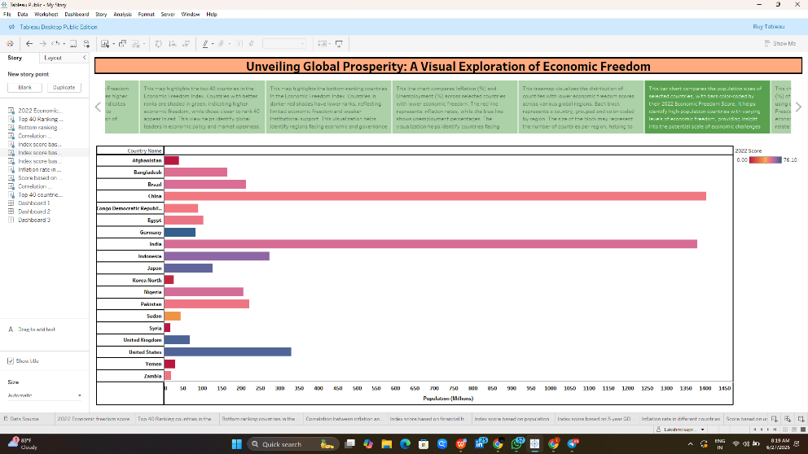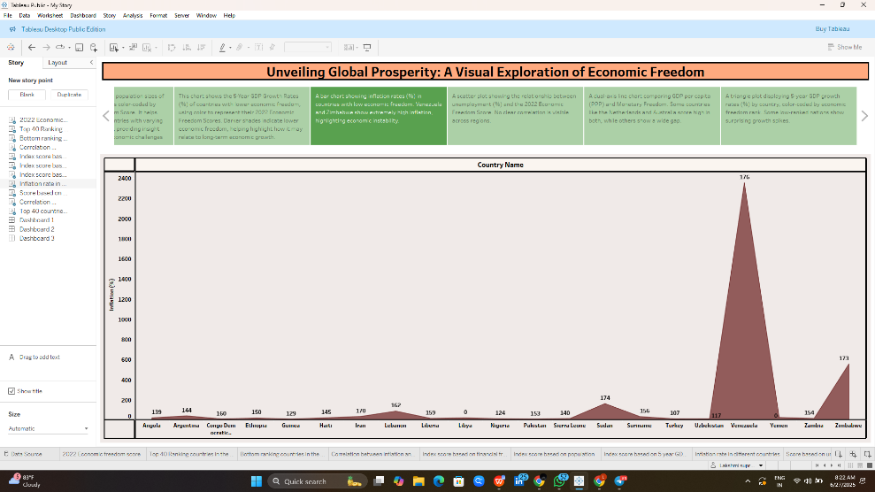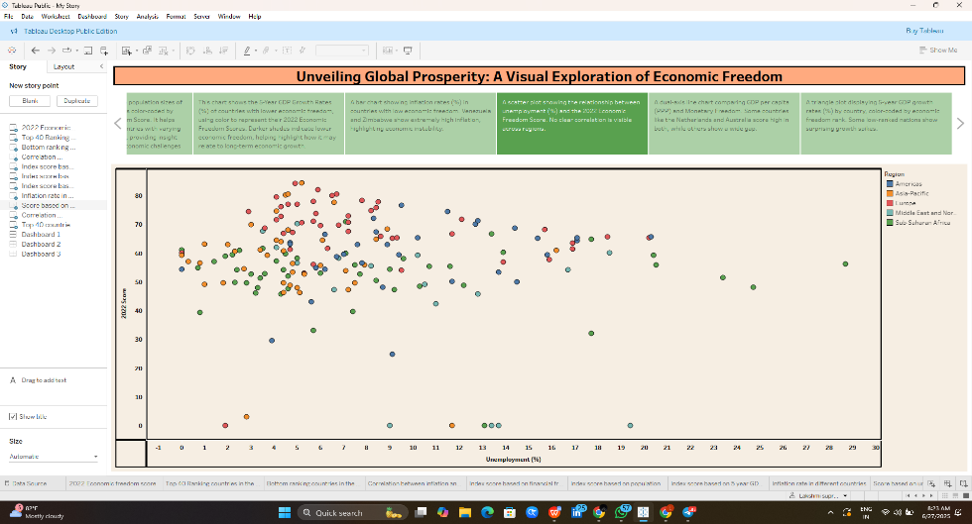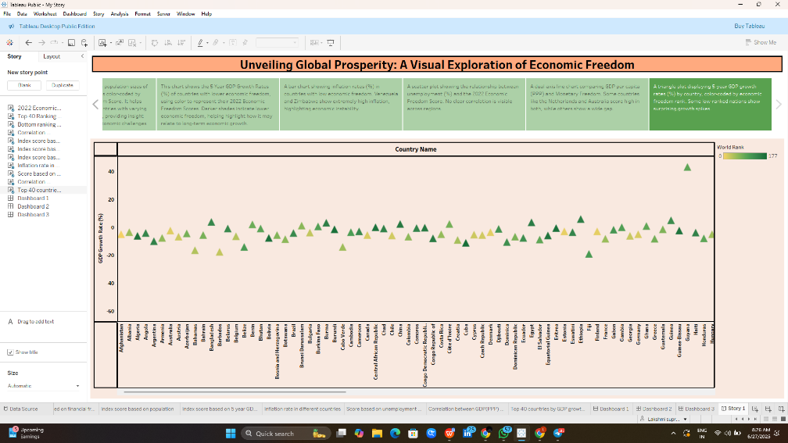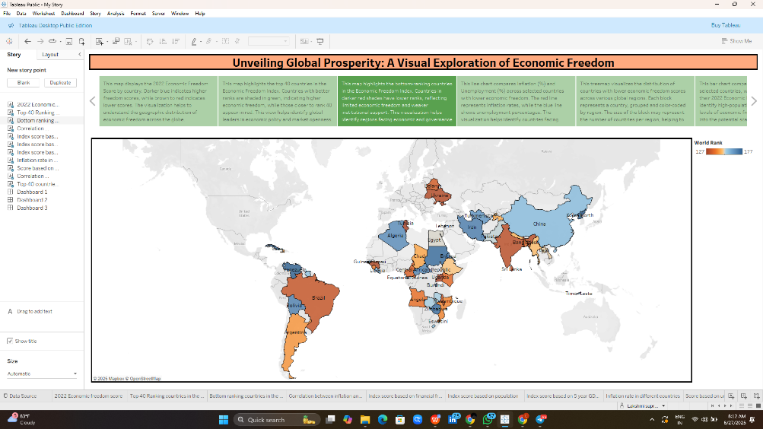

12. Conclusion
This project demonstrates that economic freedom indicators are meaningfully associated with national prosperity measures. The Tableau dashboard and story transform complex global economic data into understandable visual insights.
The interactive system allows users to compare countries, analyze policies, and interpret economic relationships effectively.

